* Select the volume or click on the volume which you have to delete.

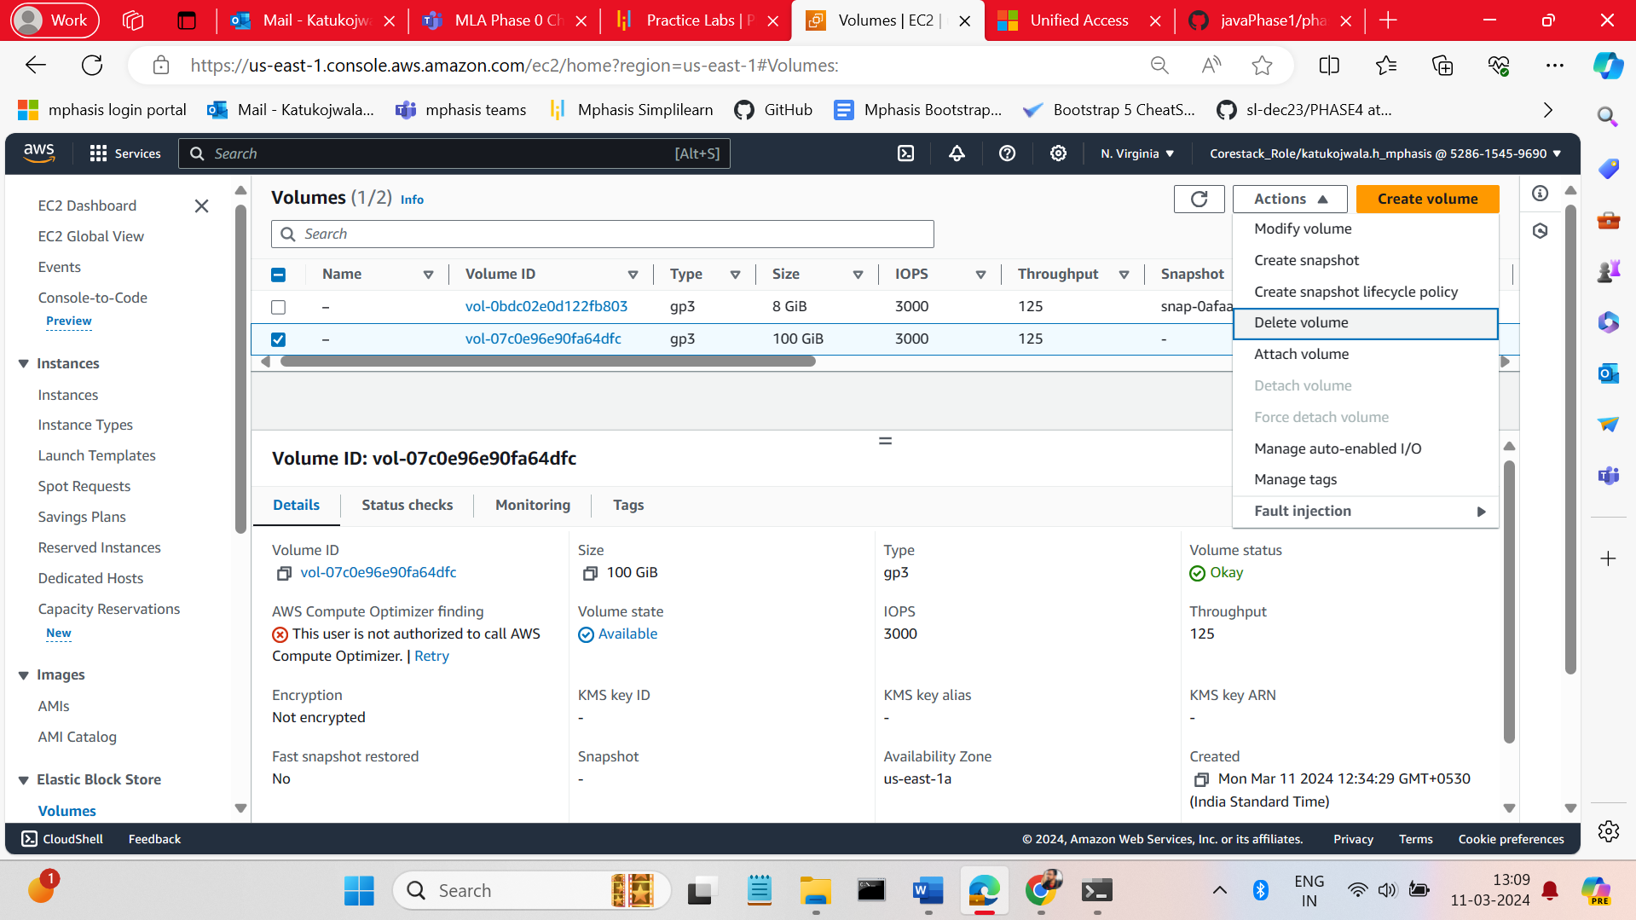 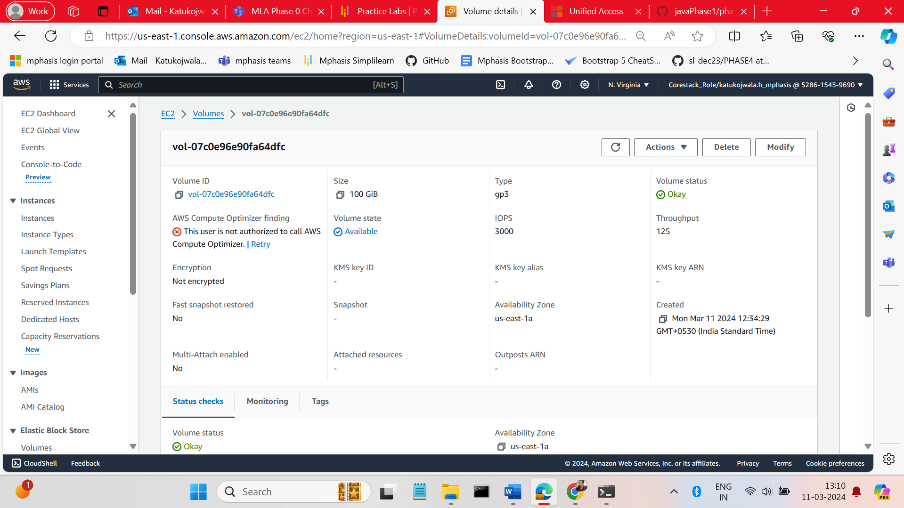

* You find the option like delete volume from the activity drop down list (or) If you click on the volume there is an option like delete volume. Click on the button any button.

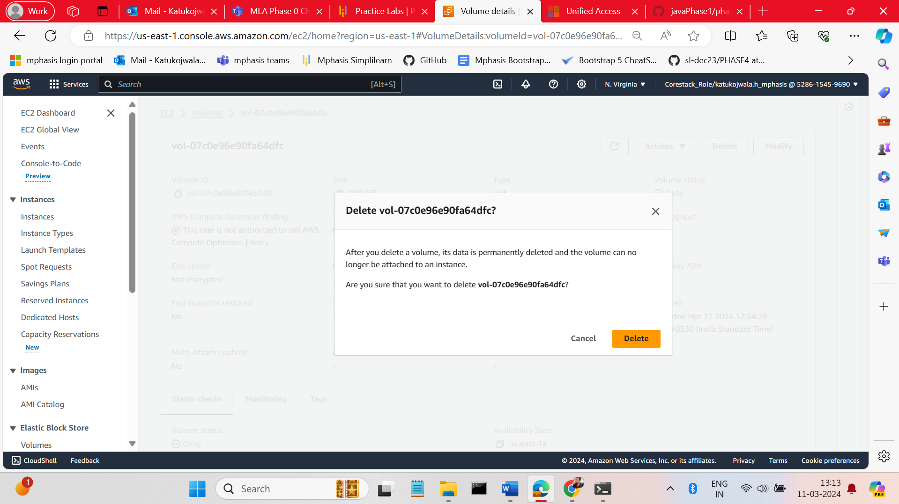

* An alert message will be popup for the conformation click on t delete button

